**ANNA UNIVERSITY : CHENNAI 600 025**

**BONAFIDE CERTIFICATE**

Certified that this project report “**Keyword Searching**” is the bona-fide work of **VIRANTH D (REGISTER NO:1915025), YOGESH V (REGISTER NO: 1915019) ,** and **MARISWARAN S (REGISTER NO:1915022),** who carried out the project work under my supervision.

|  |  |
| --- | --- |
| **SIGNATURE**  **Ms.V.ANITHA M.E.,**  **Supervisor**  Assistant Professor Department of IT,  National Engineering College (An Autonomous Institution) K.R.Nagar, Kovilpatti.628503. | **SIGNATURE**  **Dr. K.G.SRINIVASAGAN M.E.,Ph.D.,**  **Head of the Department**  Professor and Head  Department of IT,  National Engineering College  (An Autonomous Institution)  K.R. Nagar, Kovilpatti.628503. |

Submitted to the **Project(19IT67C)** Viva-Voce Examination held at National Engineering College on …………………………

# Internal Examiner External Examiner

**ACKNOWLEDGEMENT**

First and foremost, we would like to thank God Almighty for showering his blessings throughout our life. He has been the tower of our strength in each step of our work. We take the privilege to express hearty thanks to our parents for their valuable support and effort to complete the project work.

We would like to express our deep sense of gratitude and respectful regards to our director **Dr. S. Shanmugavel B.Sc., D.M.I.T., Ph.D.,** for giving an opportunity to do this work.

We have great pleasure in acknowledging our Principal **Dr. K. Kalidasa Murugavel M.E., Ph.D.,** for extending his full support to undergo this work.

We express our profound thanks to our beloved Head of the Department **Dr. K.G. Srinivasagan M.E., Ph.D.,** for extending his full support and providing various facilities during the project work

We would like to thank our project guide **Ms. V.Anitha M.E.,** Assistant Professor , Department of Information Technology, whose valuable guidance, technical support and suggestions helped us for doing the project work.

We express our gratitude to our faculty in-charge **Mrs. M. Manimegalai M.E.,** Assistant Professor, Department of Information Technology for their valuable guidance at each and every stage of the project.

We extend our hearty thanks to our tutors and class in-charges for their valuable guidance. We are grateful to all the staff members and our dear friends for their valuable suggestion and co-operation for this project work.

# ABSTRACT

This project discusses the various approaches that can be taken to solve the book searching problem. Searching is basically a problem that requires satisfying many constraints. The methods discussed in this project are effective irresponsible of various forums. Once the keyword has been given, books, journals, research papers, previous year question papers, can be searched through it. The keyword search aims at searching books, journals, research papers, question banks for National Engineering College. Our search takes the keyword as the name of book or journal as input and the search satisfies all of the hard constraints. There will be a separate login for students, teachers and admin. Admin has all the access of the application. Admin makes any necessary updation of books, journals, research papers, etc. Staff and students have access to all the documents in the e-library and also can add their details irrespective of where they are present. The keyword searching would bring all type of documents from all the forums when the keyword is called. There would be no repetition in the documents and it immensely saves time to the users.

# TABLE OF CONTENTS

|  |  |  |
| --- | --- | --- |
| **CHAPTER NO.** | **TITLE** | **PAGE NO.** |
|  | ABSTRACT | iv |
|  | TABLE OF CONTENTS | v |
|  | LIST OF FIGURES | vii |
| 1 | INTRODUCTION | 1 |
| 2 | 2.1 LITERATURE SURVEY | 2 |
|  | 2.2 EXISTING SYSTEM | 8 |
|  | 2.3 PROPOSED SYSTEM | 9 |
|  | 2.4 OBJECTIVE | 10 |
|  | 2.4.1 SYSTEM REQUIREMENTS | 10 |
|  | 2.4.2 DATABASE STRUCTURE | 11 |
| 3 | PROPOSED METHODOLOGY | 14 |
|  | 3.1 MODULES | 14 |
|  | 3.2 MODULES DESCRIPTION | 15 |
|  | 3.2.1 REGISTRATION | 15 |
|  | 3.2.2 LOGIN | 16 |
|  | 3.2.3 HOME PAGE | 15 |
|  | 3.2.4 CREATE QUESTIONS | 16 |
|  | 3.2.5 VIEW QUESTIONS LIST | 16 |

|  |  |  |
| --- | --- | --- |
|  | 3.2.6 SESSION PAGE | 16 |
|  | 3.2.7 SEARCH MODULE | 16 |
| 4 | RESULT & ANALYSIS | 17 |
| 5 | CONCLUSION & FUTURE WORKS | 21 |
|  | 5.1 CONCLUSION | 21 |
|  | 5.2 FUTURE WORK | 21 |
|  | REFERENCES | 22 |
|  | ANNEXURE | 23 |

**LIST OF FIGURES:**

|  |  |  |
| --- | --- | --- |
| **Fig. NO.** | **NAME OF THE FIGURE** | **PAGE NO.** |
|  | EMPATHY MAP | 6 |
|  | CUSTOMER JOURNEY MAP | 7 |
|  | AUTHENTICATION PAGE | 12 |
|  | ADMIN PAGE | 14 |
|  | DASHBOARD | 20 |
|  | EDIT QUESTIONS | 21 |
|  | VIEW QUESTIONS DETAILS | 23 |
|  | USER SESSION DETAILS | 25 |
|  | FORGOT PASSWORD | 26 |

# CHAPTER 1 INTRODUCTION

The demand for a single integrated, easy-to-use, access to information applications and people within a network of users is increasing more and more. In the higher education context, faculty record management portals are designed to increase accessibility to almost everything that a faculty associated with the campus needs. Once logged in, faculty have access to a variety of details in different category databases.

They can store their details according to their category. One obvious reason for universities to use these portals is to improve faculties’ productivity and satisfaction, which is not always the case for reasons related mainly to portal design. A considerable body of Information Systems research is currently taking place to explore acceptance factors in web services adoption. There is also a growing concern that certain novel technologies, such as the mobile web, may bring additional adoption issues that will not necessarily be uncovered by simply testing existing theories in a new context. Another concern is the suitability of some design factors in particular web application areas, such as university context, compared with other application areas.

Most of the previous research in the Staff Portal context focused on web usability, mainly from desktop and laptop computers. As costly as it could be, these mobile sites, when implemented without assessing user preference, could hold usability challenges. So, we had this web application to use this portal. This portal was created for the convenience and academic purpose of students and staffs of National Engineering College. By this they can download the resources in the portal with the internet anywhere without visiting to the library.

# CHAPTER 2

* 1. **LITERATURE SURVEY**

As per the survey, many applications can help sending messages and e-mail using Android- based phones/tablets. Each app has its unique features. Some existing apps were sending messages and mail to only one contact. But unfortunately, the application lacked support for the or college system.

Some applications were designed to make a call and send a message, but there is no option to send a group message. These applications had their features and lack some advancement in comparison to one another. Apart from the actual projects they consulted, they also researched the background of this field and studied the basics and foundations necessary to carry out this project. It would give access to the person's contact id makes to contact them, also provided by the Proposed App. It would consider the contact id of the authority as a primary key in the database, all actions like group chat and direct-messages are done with the help of the primary key. It would also perform searching by using the users' names in the department office or their institution. Updating the institution information is carried out only by the higher officials, they would provide the source database to them who can access it by giving their username and password. The search operation is time-consuming and easy in the proposed APP. In short, using this APP, the user can find out the Opportunities & Information of any event around the Institution by having new information about them.

The authorized user could search the student information by giving the contact id, name of the student, and email-id of the particular student of the institution. This model (Android- based) application could make a group chat and send a message to the students specified by the user. Authorized users only can use this application by downloading the apk. file. The head of the departments only has access to the database and can add, modify or delete the student information of the departments of the institution. The authorized user can search the student information by giving the contact id, name of the student, and email-id of the particular student of the institution.

Aakanksha Tashildar et al.[1] had developed a flutter based mobile application for- Billing and Reward system. The redeem point or point system emphasizes on the principle that the more money they spend, the more points they get in return so that they could redeem those points in the future purchase. Each time a customer purchases something, they get a definite sum of points depending on how much they’ve purchased ie., money spent. For example, customers earn 10 points for every Rs.1000 they spend online in the app. Further, customers can direct these points towards future purchases. To further enhance customer engagement, they have developed a mobile application where the users are facilitated to manage their accounts, buy new products, check their point status, redeem points, and so forth. By rewarding the customers with redeemable points, they increase their customer’s average order value and encourage them to invest in their brand, and their likeliness to switch to a competitor decreases.

Wenhau Wu,[2] described in “React Native vs Flutter, Cross-Platform Mobile Application Framework”, Thesis March 2018. Flutter had a bright future. Sophisticated design from React Native are well preserved with Flutter’s own evolvement. The consistency and tidiness in syntax and SDK level does bring joy to developers. Rendering widgets through a dedicate engine boosts the performance and eliminates pollutions from the OEMs. To conclude, both React Native and Flutter have greatly proven the value of cross-platform mobile application framework. The efficiency and convenience regarding to development can surely boost the speed of pushing the product to the market. Producing a high quality and beautiful application for all mobile platforms had never been this easy before. As a trade-off, certain performance loss, when comparing to native application, is reasonably acknowledged and allowed.

Shady Boukhary et al. [3] described an clean approach to “Flutter Development through the Flutter Clean architecture package”, IEEE 2019. This is the stuff they're used to from "unclean" Flutter architecture. They obviously need widgets to display something on the screen. These widgets then dispatch events to the Bloc and listen for states. The data layer consists of a Repository implementation (the contract comes from the domain layer) and data sources - one is usually for getting remote (API) data and the other for caching that data. Repository is where they decide if they return fresh or cached data, when to cache it and so on. The Remote Data Source will perform HTTP GET requests on the Numbers API. Local Data

Lizeth Ghandi et al.[4] built up an application, existing software development processes to suit their purpose, given the existing specific constraints. Such adjustments can introduce variations and new trends in existing processes that in many occasions are not shared with the scientific community since there is no official documentation, thus justifying further research. In their paper, they present a study and characterization of current mobile application development processes based on a practical experience. The result of the present study is the identification of mobile software development processes, namely agile approaches, and also of shortcomings in current methodologies applied in industry and academy, namely the lack of informed and experienced resources to develop mobile apps.

Zhang et al.[5] described that the usability of mobile applications is an emerging research area that faces a variety of challenges due to unique features of mobile devices, such as changing connectivity conditions and mobility. Traditional guidelines and methods used in usability testing of desktop applications may not be directly applicable to a mobile environment. Additionally, there is a severe shortage in the usability of mobile student portals. One of the few studies on mobile educational portal suggests that students’ motivation can be stimulated if authenticity is introduced in the portal’s content and design.

Achal Agrawal et al. [6] had incorporated in the “Comparison of Flutter with Other Development Platforms”. In today’s world ease of development is the thing all developers are looking for and flutter has come up with the required platform to support development of applications for both Android and iOS. Developers are enforced to either construct the same application numerous times for various OS (operating systems) or accept a low-quality similar solution that trades native speed and accuracy for portability. Flutter is an open- source SDK for developing high-performance and more reliable mobile applications for operating systems like iOS and Android.

Chunnu Khawas et al. [7] described in “Application of Firebase in Android App Development”, where they highlights on the study about Google provided Firebase API and its unique features. Their paper helps in studying how to use Firebase in the Android application according to the developer requirement. That also helps in making android apps faster and efficient as no PHP is required as a third-party language to communicate with the database. It provides a secure channel to communicate with the database directly from JAVA. The study material is based on the data provided online and referring to the examples given. Google had been updating Firebase on regular basis, AdSense is the beta phase of Firebase. It can not only be used in Android but also to connect cross platform.

Thulasi Krishna NP [8], (2016) had described that a portal is a specially designed website that helps to bring informations together from different sources in a uniform way. Online Student Portal (OSP) is a web application which is mainly focused on one who are trying to learn known as students and the one who trying to teach a learner known as teachers. The members in their portal can exchange informations in different formats such as video, images, pdf etc. Their application will be very useful for students to get updated to latest informations and to communicate with world wide learners. OSP provides services like, online book shop, online courses, forums, communities, study materials, news and eventsPortal is a specially designed website that helps to bring informations together from different sources in a uniform way. Their application will be very useful for students to get updated to latest informations and to communicate with world wide learners. OSP provides services like, online book shop, online courses, forums, communities, study materials, news and events.

Shilpa Bilawane et al. [9] proposed in “Information System Based on College Campus”. Today in college’s student details are entered manually. The student separate records are tedious task. Referring to all these records and updating is needed. There is a chance for more manual errors. As mobile devices have become popular; there appears a new trend to release all kinds of campus information by intelligent mobile terminals. We describe a network for distributing campus information among lecturers and students. The concept of developing campus information system is to ensure that student can access information at any time, at any locations and ad-hoc basic. Information System helps the students and lecturers on campus to find and access information based on ad-hoc basic, which is of interest and relevant to students or lecturers through a smart phone.

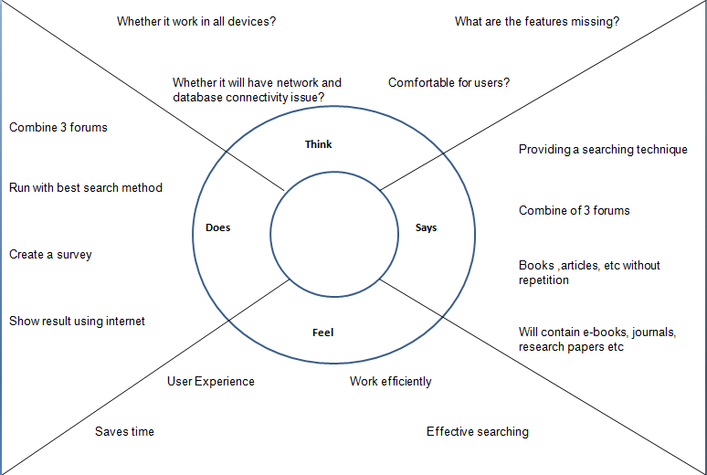

**Fig.2.1 Empathy Map of Keyword Searching**

Our project would combine the forums such as IEEE(ASPP), EBSCO, Science Direct, DELNET and provide the required result by taking a single word as a keyword. It reduce the time consumption and also work efficiently than the existing system. There would be separate login for users so that can take survey of user login. The User Experience and comfort would be better than the existing system.

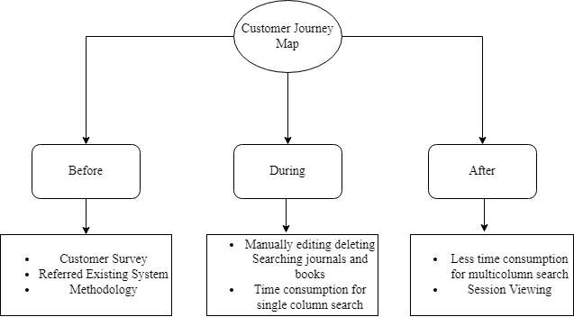

**Fig. 2.2 Customer journey of Keyword Searching**

We took customer survey for the betterment of the project and worked the on the basis of the customer survey. We also took reference from the existing system to overcome the difficulties facing in it. The current search would contain features like updation, deletion, login, signup, user session than the existing system.

# EXISTING SYSTEM

In the existing system they developed this portal as web application for students. There are many applications e-documents in e-library for the student and staffs for their academic purposes but there is no proper searching technique to find the document properly. Even searching for a single book will take lot of time to find and require a good internet connection to be fully functional. And the main problem with the existing model is that no proper searching technique for our purpose. And they had used it just for usage of some users but now it is using by most. So, the useful information shared using these platform gets lost in millions of other things within them.

# PROPOSED SYSTEM

In the proposed system, we have planned to add the following features and updates:

* + - Platform – Where the students and staff can search the required document for their academic purpose.
    - Database Updating – Adding all the document information, based on their document, into the MySQL Database.
    - UI Designing – Changing the application's user interface to be easier for the application users to interact with.
    - Registration – A new user can register their profile so that they can login their profile to access the platform.
    - Admin login – Adding the options of maintaining of data, information and makes sure of the activity in the platform, the messages are shared in correct platform and are real and not a scam.
    - Staff login – Can view and download the required document for their purpose and can also add their books, journals, quesion bank and also research papers.
    - Student login – Can view and download the required document for their academic purpose.
    - Active status – Option to show how may login in a day and how many login are using the portal currently status of the students on their profile so that others may know their status and contact them.
    - Forgot Password – Option to login to the account if the password is forgot.

# OBJECTIVE

The main objective of this proposed application is to design a keyword searching, for library. This system is developed to solve the general need of the user while using the library portal and provides a lot of facilities to their users. The system is very user- friendly, and it is anticipated that administrators and students will easily access the system's functions.

# SOFTWARE REQUIREMENTS

* + - * Jsp, Servlet
      * Tomcat Server(Apache)
      * Xampp

**Eclipse Workspace:**

Eclipse Workspace is a lightweight but powerful source IDE which runs on your desktop and is available for Windows, macOS, and Linux. Eclipse is written mostly in Java and its primary use is for developing Java applications,[7] but it may also be used to develop applications in other programming languages via plug-ins, including Ada, ABAP, C, C++, C#, Clojure, COBOL, D, Erlang, Fortran, Groovy, Haskell, JavaScript, Julia, Lasso, Lua, NATURAL, Perl, PHP, Prolog, Python, R, Ruby (including Ruby on Rails framework), Rust, Scala, and Scheme.

**JSP:**

A **popular general-Java Server Page** that is especially suited to web development. Fast, flexible and pragmatic, JSP powers everything from your blog to the most popular websites in the world. Currently, use version 8.0.53.\

**XAMPP:**

XAMPP is the most popular JSP development environment XAMPP is a completely free, easy-to-install Apache distribution containing MySQL, Tomcat. The XAMPP open-source package has been set up to be incredibly easy to install and use.

# DATABASE STRUCTURE

Through sql tools in Eclipse Workspace, the user can efficiently integrate real-time database into app. On the client-side implementation, user can initialize, configure and build the database with minimal effort. On the server-side, phpMyAdmin ensures reliable infra-management services for user’s database for the app. This readme provides essential information on the database structure, supplementary features.

How it works

* + - * Admin creates user
      * User gets log in id
      * User enters into dashboard
      * Save details in various category.

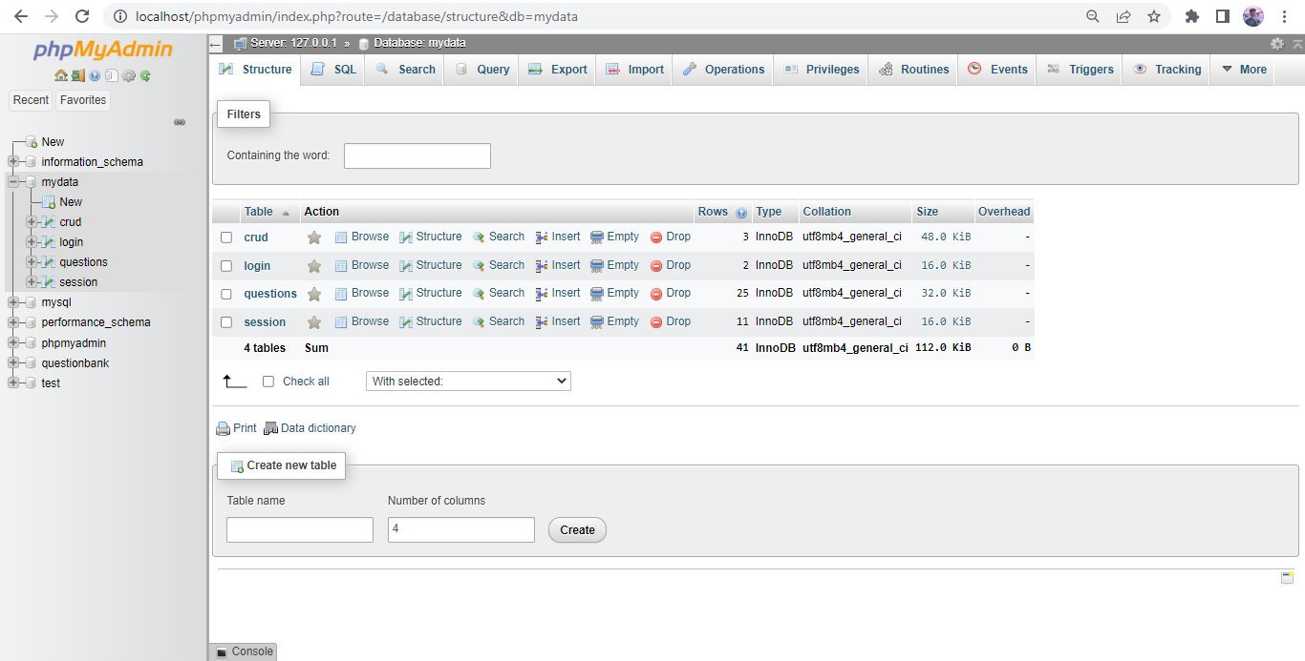

# Fig.2.3 Database Structure

In order to use the features of the phpMyAdmin database in Eclipse Workspace we

must install sql tools and Mysql server. We can connect to the database in phpMyAdmin using

sql tools by entering host name, user name, password and database name.

phpMyAdmin is a free software tool written in PHP that is intended to handle the

administration of a MySQL or MariaDB database server. You can use phpMyAdmin to

perform most administration tasks, including creating a database, running queries, and addinguser accounts. The base idea for this project is to store book,students details without collision. So that we create separate database for each user. In that particular database, user can save, edit, delete details according to their wish at any time. This won’t affect another user.

At first, we collect user information from the user at the profile creation time.

Program auto-generates the user id that user id and the password given by the user alone stored

in separate database. All user ids and passwords are stored in that database. That database is

used by Admin. For each user id there creates a separate database using sql query. In that

separate database there are 4 tables to store user records. User details table contains users’ information which was given by the user at the creation time. Login details table contains users’ login details with date and time.

The Question table contains the field such as book_id, deptid, regulation, month, year, subcode, subname, link.The signup table contain fields such as username, password, email, phone number, department, year.The sesssion table contains fields such as sessionid, name, mail, year, date and time.The userid, sessionid, bookid are the primar keys that are used in the table which can also be used as foreign key on the other tables.

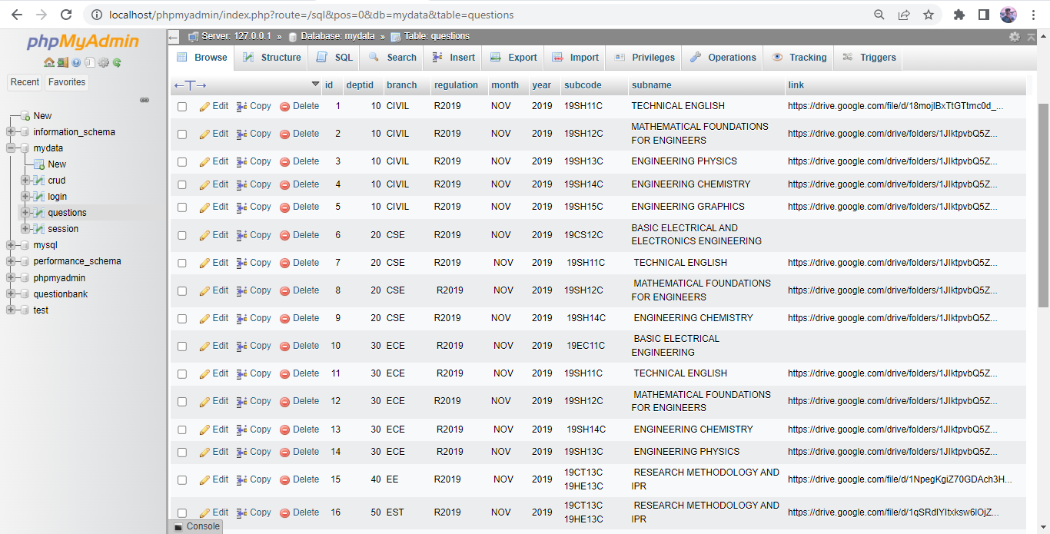

**Fig.2.4 Question details table**

**CHAPTER 3**

**PROPOSED METHODOLOGY**

# MODULES

* + - Admin Login
    - User Login
    - Admin – Create a question link
    - Admin – Delete,Edit a question link
    - Admin – View users details and session details
    - Student – view the question link
    - Student – Password Change
    - Student – Session time
    - Student – Edit profile

Fig.3.1 shows the design of the system. It includes: create question, delete question view question, save user details and edit user password

# Fig. 3.1 System Design

* 1. **MODULES DESCRIPTION**

# 3.2.1 Admin Login

This module helps us to login into the admin account. Every website needs an admin to maintain it properly. In this module, we can create users, delete users, and view users. Admin can log in by entering admin ID, and password.

# User Login

Once the registration is completed, the user can log in to their account using generated staff ID and their password. This module helps us to login into the faculty (user) account. With this module, we can separate users. So that one cannot view another one’s detail without their authentication. They should enter their credentials on the screen. Once they click the login button, their credentials will be checked with the list of users in the phpMyAdmin database. If it matches, then continues to their dashboard.

# 3.2.3 Admin – create a question

In this module, we can create a question paper link. Users fill up the required details with the help of the admin. They have to enter all their details and set their ID for the Question paper. Once they click Add new button the details entered by the Admin. The details are stored in the separate database for the question and their generated ID and the other details are stored in the questions table for login credentials.

# Admin – Delete a question

In this module, we can delete a question details along with their data. Once the question link is invalid their records need not be maintained. So, once they retrieve all the pieces of information the question link will be deleted by using this module. The admin can delete the Question paper details profile by selecting their ID

# Admin – View users

In this module, the admin can view the list of the users’ user IDs who are all the sign up the website

# User- view question

In this module, a user can see the Questions and click the view button via the user download the question.

# User – Session Details

In this module, a user can see the session details. And the user search particular date whether he is login or not . Once they click submit button their details will be added to their session in their separate database.

# User – download

In this module, a user can download the various years questions . They have to fill in the required details on the screen. Once they click download button their question paper PDF format will be downloaded. The question will open in chrome browser

# User – Other Details

In this module, a admin can see the users session details. How many time the user is login the website.

# User –Edit Password

In this module, a user can edit his password. The OTP will automatically generated and the OTP and generated OTP is same the Forgot Password page is open and the user change his password

# CHAPTER 4 RESULT AND ANALYSIS

The admin and the user share the login page. They will be differed only based on their credentials. If the credentials belong to the admin, then it redirects to the admin page. If the credentials belong to the user, then it redirects to the user dashboard.

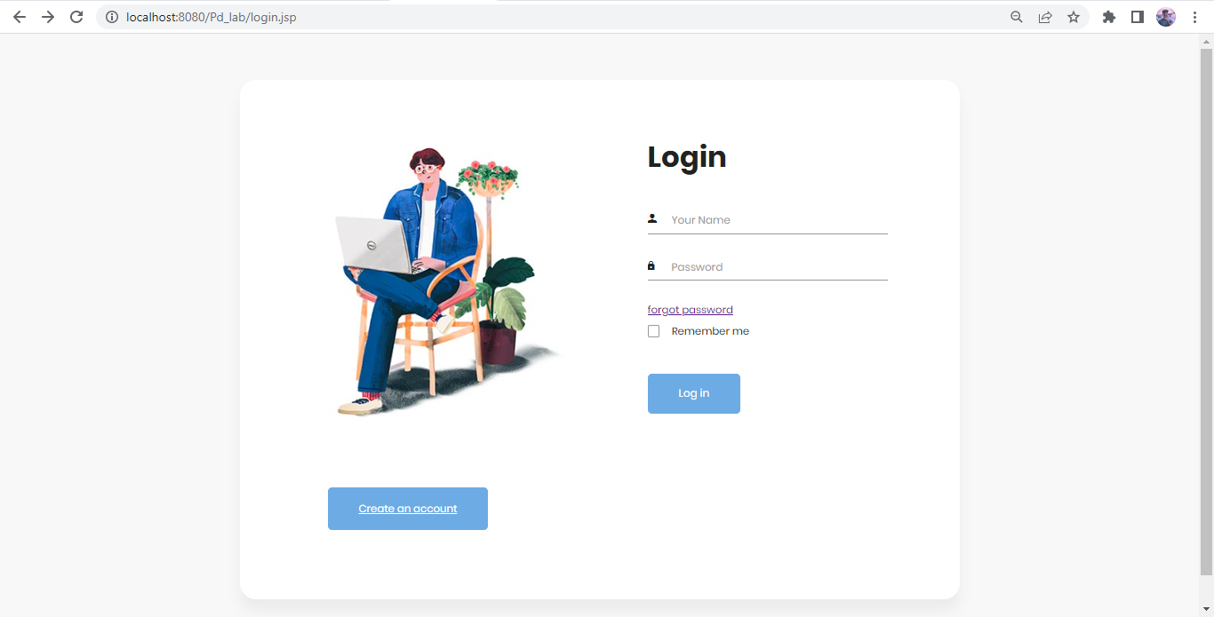

# Fig.4.1 Login page for the Staffs and students

The fig.4.1 shows the user to access the books, E-journals, Questions to authenticate via the login page. If the username and password is matched the response will be send to the User panel. If not matched the response will be send to the signup page

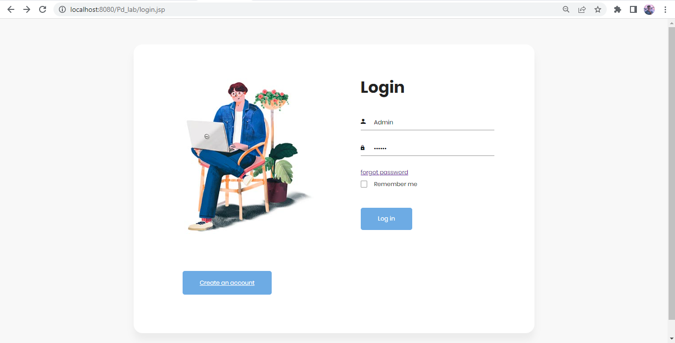

# Fig.4.2 Admin login page for Admin

# 

# The fig. 4.2 shows the Admin login page the admin also have username password for the security purpose.

# C:\Users\HP-PC\Downloads\Music\image (3).png

# Fig. 4.3 Admin Dashboard for to perform the operations

# The Fig 4.3 contains Questions, books list and perform adding new records, edit the records, delete the records,user signup details and session details

# C:\Users\HP-PC\Downloads\Music\unnamed (1).png

# Fig.4.4 View Question paper details – subject code, year, subject name etc.

# The fig. 4.4 is view page, which contains 7 records and the user click the view button the page will be opened the question papers entire link will be displayed

# C:\Users\HP-PC\Downloads\Music\image (2).png

# Fig.4.5 Sign up page for the users

# The user first signup our web portal and access all questions and eBooks. It common for the student and staff

Once they successfully registered their profile their auto-generated ID will be displayed. With that ID, they can log in to their dashboard. Their login authentication will be checked with the phpMyAdmin database.

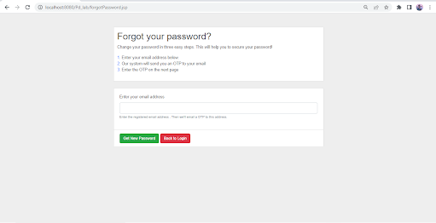

# Fig.4.6 forgot password for sending OTP to users mail

The fig. 4.6 It send the OTP to the user for updating new password. The OTP will auto generated.

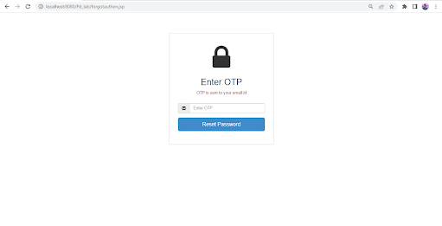

**Fig.4.7 – OTP validation for Password Reset**

The user entered OTP and generated OTP is matching it will move to password upgradation page. If not matched the response will send login page

**CHAPTER 5**

# CONCLUSION AND FUTURE WORK

**5.1 CONCLUSION**

The era of web technology opens the window to web applications. It is time to change our daily routine. So the project introduced as “KEYWORD SEARCHING”, the searching technique which would be the college application. The system will be very useful for students to get their required documents in an easy manner.

# 5.2 FUTURE WORK

The application provides an excellent user experience and has many features. In the future, we can add some components. The moderator could be able to manage the messages and information which is shared in the channel is related to that channel and are real and not scam. We also include tags for user to choose the tags he wish to follow and join channels, as per hi/her wish. And we have to include the feature of upvote -- is a method by which users can signal their approval or support for a post. Upvotes move a post towards the top of the site, and they are a way to measure how many people approve of the content.

**REFERENCES**

1. Tashildar, Aakanksha, Nisha Shah, Rushabh Gala, Trishul Giri, and Pranali Chavhan. "Application development using flutter." International Research Journal of Modernization in Engineering Technology and Science 2, no. 8 (2020): 1262-1266.
2. Wu, Wenhao. "React Native vs Flutter, Cross-platforms mobile application frameworks."

International Research Journal of Modernization in Engineering Technology and Science 2, no. 32 (2020): 1380-1384

1. Boukhary, Shady, and Eduardo Colmenares. "A clean approach to flutter development through the flutter clean architecture package." In 2019 International Conference on Computational Science and Computational Intelligence (CSCI), pp. 1115-1120. IEEE, 2019.
2. Ghandi, Lizeth, Catarina Silva, Danilo Martínez, and Tatiana Gualotuña. "Mobile application development process: A practical experience." In 2017 12th Iberian Conference on Information Systems and Technologies (CISTI), pp. 1-6. IEEE, 2017.
3. Istepanian, Robert SH, Emil Jovanov, and Y. T. Zhang. "Guest editorial introduction to the special section on m-health: Beyond seamless mobility and global wireless health-care connectivity." IEEE Transactions on information technology in biomedicine 8, no. 4 (2004): 405-414.
4. Khawas, Chunnu, and Pritam Shah. "Application of firebase in android app development-a study." International Journal of Computer Applications 179, no. 46 (2018): 49-53.
5. Thulasi Krishna, N. P. "Online student portal—a learning portal for every student." Int. J. Eng. Devel. Res.(IJEDR) 4, no. 3 (2016): 319-321.
6. Rakshith, M. D., N. Harshavardhan, and Deeksha Nayak. "MAHITHI: An Android Application to Monitor Student’s Academic Activities."
7. Saleh, Hassan Hadi, Israa Adnan Mishkhal, and Riyad Salam Mohammed. "Implementing an Electronic Management System for Managing Graduate Students’ Information in Iraqi Universities." In IOP Conference Series: Materials Science and Engineering, vol. 928, no. 3, p. 032012. IOP Publishing, 2020.

**ANNEXURE**

**Index.jsp**

<%@page import="java.sql.DriverManager"%> **// java database connection required packages**  
<%@page import="java.sql.ResultSet"%>  
<%@page import="java.sql.Statement"%>  
<%@page import="java.sql.Connection"%>  
<%@page contentType="text/html" pageEncoding="UTF-8"%>  
<!DOCTYPE html>  
<html>  
    <!-- Latest compiled and minified CSS -->  
<link href="<https://cdn.jsdelivr.net/npm/bootstrap@5.1.3/dist/css/bootstrap.min.css>" rel="stylesheet"> **//bootstrap CDN link**  
<link rel="stylesheet" href="css/style.css">  
<!-- Latest compiled JavaScript -->  
<script src="<https://cdn.jsdelivr.net/npm/bootstrap@5.1.3/dist/js/bootstrap.bundle.min.js>"></script>  
<style> **// internal css for the index page**  
   <style>  
        body{  
        background-color : #377D71;  
        }  
            .container{  
                width: 1500px;  
        background-color: #faf8f0;  
        padding: 20px 20px 20px 20px;  
        border-radius: 20px;  
        }  
        .con{  
            width: 800px;  
            margin-left: 50vh;  
            background-color: #faf8f0;  
            border-radius: 20px;  
            padding: 10px 10px 10px 10px;  
        }  
        hr{  
            border: #000000 1px solid;  
        }  
        .form-group{  
        padding : 5px 20px 5px 20px;  
        }  
        p{  
        font-weight : bold;  
        font-color : #000;  
        font-size : 20px;  
        }  
        .num{  
        background-color : #000;  
        }  
        </style>  
</style>      
<p><br/></p>  
    <body>  
        <%  
            String host= "jdbc:mysql://localhost:3306/mydata"; **//make a database connection using java**  
            Connection con = null;  
            Statement stmt = null;  
            ResultSet rs = null;  
            Class.forName("com.mysql.jdbc.Driver");  
            con = DriverManager.getConnection(host,"root","");  
            stmt = con.createStatement();  
            String str = (String)session.getAttribute("user"); **// get the user name beyond session attribute**  
        %>  
        <div class="container">  
        <div>  
        <div><h3>Hello, <%=str %> Welcome to panel</h3></div>  
            <div class="row">  
                <div class="col-md-3">  
                    <marquee behavior="" direction="">  
                        <h3>Question List</h3>  
                    </marquee>  
                </div>  
                <div class="col-md-3">  
                    <form action="" method="get">  
                        <input type="text" name="q" id="q" class="form-control" placeholder="Search Here..." > **//search box to search resource**  
                         
                    </form>  
                </div>  
                <div class="col-md-3">  
                    <a href="addnew.jsp" class="btn btn-primary">Add New</a>  
                </div>  
                  <%  
                         if(str.equals("Admin")){ **//whether the login user is admin or user or staff**  
                         %>  
  <div class="col-md-3">  
                    <h3><a href="usersession.jsp" class="btn btn-success">Users Session</a></h3>  
                </div>  
                <div class="col-md-3">  
                    <h3><a href="userdetails.jsp" class="btn btn-success">User details</a></h3>  
                </div>  
                         <%  
                         }else{  
                         %>  
                         <div class="col-md-3">  
                    <h3><a href="usersession2.jsp" class="btn btn-success">Users Session</a></h3>  
                </div>  
                         <% }%>  
                          <div class="col-md-3">  
                    <h3><a href="logout.jsp" class="btn btn-success">logout</a></h3> **//Session invalid for logout**  
                </div>  
            </div>  
            <hr>  
            <table class = "table table-bordered table-striped table-hover">  
                <thead>  
                 
                     <tr>  
                         <th>ID</th>  
                         <th>branch</th>  
                         <th>Regulation</th>  
                         <th>month</th>  
                         <th>Year</th>  
                         <th>subject code</th>  
                         <th>subject name</th>  
                         <th>link</th>  
                         <th class="text-center">View</th>  
                         <%  
                         if(str.equals("Admin")){  
                         %>  
                         <th>Action</th>  
                         <%  
                         }  
                         %>  
                     </tr>  
                </thead>  
                <tbody>  
                    <%  
                         String query = request.getParameter("q");  
                         String data;  
                         if(query!=null){  
                            data = "select *from questions where branch like'%"+query+"%' or regulation like'%"+query+"%' or month like'%"+query+"%' or year like'%"+query+"%' or subcode like'%"+query+"%' or subname like'%"+query+"%'";  
                            %>  
                            <a href="index.jsp" class="btn btn-primary">back</a>  
                            <hr>  
                             
                       <% }  
                        else  
                            data =  "select *from questions order by id desc"; **// database code for searching the resource**  
                           rs = stmt.executeQuery(data);  
                         while(rs.next()){  
                    %>  
                    <tr>  
                        <td><%=rs.getInt("id")%></td>  
                        <!-- <td><%=rs.getString("deptid")%></td> -->  
                        <td><%=rs.getString("branch")%></td>  
                        <td><%=rs.getString("regulation")%></td> **//the question information to view user get from the backend**  
                        <td><%=rs.getString("month")%></td>  
                        <td><%=rs.getString("year")%></td>  
                        <td><%=rs.getString("subcode")%></td>  
                        <td><%=rs.getString("subname")%></td>  
                        <td><a href='<%=rs.getString("link")%>' target="_blank" class="btn btn-primary">click</a></td>  
                        <td><a href='view.jsp?u=<%=rs.getInt("id")%>' class="btn btn-primary">view</a></td>  
                         <%  
                         if(str.equals("Admin")){  
                         %>  
  <td class="text-center">  
                            <a href='edit.jsp?u=<%=rs.getInt("id")%>' class="btn btn-warning">Edit</a> **// Edit a field in database** **only for the Admin purpose**  
                            <a href='delete.jsp?d=<%=rs.getInt("id")%>' class="btn btn-danger">Delete</a> **// Delete a field in database only form Admin purpose**  
                        </td>  
                         <%  
                         }  
                         %>  
                    </tr>  
                    <%  
                     }  
                    %>  
                </tbody>  
             </table>  
          </div>  
        </div>  
    </body>  
     
</html>

**Session Virtualization**

<%@page import="java.sql.DriverManager"%>**//database connection required packages**  
<%@page import="java.sql.ResultSet"%>  
<%@page import="java.sql.Statement"%>  
<%@page import="java.sql.Connection"%>  
<%@page contentType="text/html" pageEncoding="UTF-8"%>  
  
<!DOCTYPE html>  
<html>  
    <!-- Latest compiled and minified CSS -->  
<link href="<https://cdn.jsdelivr.net/npm/bootstrap@5.1.3/dist/css/bootstrap.min.css>" rel="stylesheet">  
<link rel="stylesheet" href="css/style.css">**//Bootstrap CDN link**  
<!-- Latest compiled JavaScript -->  
<script src="<https://cdn.jsdelivr.net/npm/bootstrap@5.1.3/dist/js/bootstrap.bundle.min.js>"></script>  
<style>  
   <style>  
        body{  
        background-color : #377D71;  
        }  
            .container{  
                width: 1500px;  
        background-color: #faf8f0;  
        padding: 20px 20px 20px 20px;  
        border-radius: 20px;  
        }  
        .con{  
            width: 800px;  
            margin-left: 50vh;  
            background-color: #faf8f0;  
            border-radius: 20px;  
            padding: 10px 10px 10px 10px;  
        }  
        hr{  
            border: #000000 1px solid;  
        }  
        .form-group{  
        padding : 5px 20px 5px 20px;  
        }  
        p{  
        font-weight : bold;  
        font-color : #000;  
        font-size : 20px;  
        }  
        .num{  
        background-color : #000;  
        }  
        </style>  
</style>      
<p><br/></p>  
    <body>  
        <%  
            String host= "jdbc:mysql://localhost:3306/mydata"; **// make a database connection using java**  
            Connection con = null;  
            Statement stmt = null;  
            ResultSet rs = null;  
            Class.forName("com.mysql.jdbc.Driver");  
            con = DriverManager.getConnection(host,"root","");  
            stmt = con.createStatement();  
        %>  
        <div class="container">  
        <div>  
            <div class="row">  
                <div class="col-md-3">  
                    <marquee behavior="" direction="">  
                        <h3>Session List</h3>  
                    </marquee>  
                </div>  
                <div class="col-md-3">  
                    <form action="" method="get">  
                        <input type="text" name="q" id="q" class="form-control" placeholder="Search Here..." >  
                    </form>  
                </div>  
                 <div class="col-md-3">  
                   <a href="index.jsp" class="btn btn-warning">back</a>  
                </div>  
            </div>  
            <hr>  
            <table class = "table table-bordered table-striped table-hover">  
                <thead>  
                     <tr>  
                         <th>ID</th>  
                         <th>Name</th>  
                         <th>Register No</th>  
                         <th>Mail ID</th>  
                         <th>Session Date</th>  
                     </tr>  
                </thead>  
                <tbody>  
                    <%  
                         String query = request.getParameter("q");  
                         String data;  
                         if(query!=null){  
                            data = "select *from session where regno like'%"+query+"%'";  
                            %>  
                            <a href="index.jsp" class="btn btn-primary">back</a>  
                            <hr>  
                             
                       <% }  
                        else  
                            data =  "select *from session order by id desc";  
                           rs = stmt.executeQuery(data);  
                         while(rs.next()){  
                    %>  
                    <tr>  
                        <td><%=rs.getInt("id")%></td> **//displaying the data in table format by fetching from the database(Session table)**  
                        <!-- <td><%=rs.getString("name")%></td> -->  
                        <td><%=rs.getString("name")%></td>  
                        <td><%=rs.getString("regno")%></td>  
                        <td><%=rs.getString("mail")%></td>  
                        <td><%=rs.getString("date")%></td>  
                    </tr>  
                    <%  
                     }  
                    %>  
                </tbody>  
             </table>  
          </div>  
        </div>  
    </body>  
     
</html>

**ADDNEW.JSP**

<%@page import="java.sql.DriverManager"%> // **java database connection required packages**  
<%@page import="java.sql.PreparedStatement"%>  
<%@page import="java.sql.Connection"%>  
<%@page contentType="text/html" pageEncoding="UTF-8"%>  
  
<!DOCTYPE html>  
<html>  
    <head>  
        <link href="<https://cdn.jsdelivr.net/npm/bootstrap@5.1.3/dist/css/bootstrap.min.css>" rel="stylesheet">**//Bootstrap CDN link**  
        <script src="<https://cdn.jsdelivr.net/npm/bootstrap@5.1.3/dist/js/bootstrap.bundle.min.js>"></script>  
        <link rel="stylesheet" href="css/style.css">  
        <style>  
        body{  
        background-color : #377D71;  
        }  
            .container{  
                width: 700px;  
        background-color: #faf8f0;  
        padding: 20px 20px 20px 20px;  
        border-radius: 20px;  
        }  
        .con{  
            width: 800px;  
            margin-left: 50vh;  
            background-color: #faf8f0;  
            border-radius: 20px;  
            padding: 10px 10px 10px 10px;  
        }  
        hr{  
            border: #000000 1px solid;  
        }  
        .form-group{  
        padding : 5px 20px 5px 20px;  
        }  
        p{  
        font-weight : bold;  
        font-color : #000;  
        font-size : 20px;  
        }  
        </style>  
    </head>  
    <body><p><br><br></p>  
        <div class="con">  
            <hr><br>  
            <marquee behavior="" direction="left">  
                <h2>Adding New Questions</h2> **//Form for the Adding new question details**  
            </marquee>  
            <hr>  
        </div>  
       <br>  
        <div class="container">  
            <form action="" method="post">  
                <div class="form-group">  
                    <p>Branch</p>  
                    <input type = "text" name = "branch" class="form-control" placeholder="Enter the Brach" required/>  
                </div><br>  
                <div class="form-group">  
                    <p>Regulation</p>  
                    <input type = "text" name = "reg" class="form-control" placeholder="Enter the regulation" required/>  
                </div><br>  
                <div class="form-group">  
                    <p>Month</p>  
                    <input type = "text" name = "month"  class="form-control" placeholder="Enter the Month" required/>  
                </div><br>  
                <div class="form-group">  
                    <p>year</p>  
                    <input type = "text" name = "year" class="form-control" placeholder="Enter the Year" required/>  
                </div><br>  
                <div class="form-group">  
                    <p>subject code</p>  
                    <input type = "text" name = "sc" class="form-control" placeholder="Enter the subject code" required/>  
                </div><br>  
                <div class="form-group">  
                    <p>Subject name</p>  
                    <input type = "text" name = "sl" class="form-control" placeholder="Enter the subject name" required/>  
                </div><br>  
                <div class="form-group">  
                    <p>Question paper</p>  
                    <input type = "text" name = "qpl" class="form-control" placeholder="Enter the question paper link" required/>  
                </div><br>  
                 
                <div class="btn-2">  
                    <button type="submit" class="btn btn-primary">Add new</button>  
                <a href="index.jsp" class="btn btn-primary btna" >Back</a>  
                </div>  
            </form>  
        </div>  
    </body>  
</html>  
  
<%  
    String a = request.getParameter("branch"); **//Getting form details and storing into the string and it will store in the database**  
    String b = request.getParameter("reg");  
    String c = request.getParameter("month");  
    String d = request.getParameter("year");  
    String e = request.getParameter("sc");  
    String f = request.getParameter("sl");  
    String g = request.getParameter("qpl");  
    String host= "jdbc:mysql://localhost:3306/mydata";  
    Connection con = null;  
    PreparedStatement stmt = null;  
    Class.forName("com.mysql.jdbc.Driver");  
    if(a!=null && b!=null && c!=null && d!=null){  
        con = DriverManager.getConnection(host,"root",""); //**storing the data in the database using java**  
        stmt = con.prepareStatement("INSERT INTO questions (branch, regulation, month, year, subcode, subname, link) VALUES ( ?, ?, ?, ?, ?, ?, ?);");  
        stmt.setString(1,a);  
        stmt.setString(2,b);  
        stmt.setString(3,c);  
        stmt.setString(4,d);  
        stmt.setString(5,e);  
        stmt.setString(6,f);  
        stmt.setString(7,g);  
        stmt.executeUpdate();  
        response.sendRedirect("index.jsp"); **//The page response will be move to the index page**

**EDIT.JSP**

<%@page import="java.sql.DriverManager"%> **// java database connection required packages**  
<%@page import="java.sql.Statement"%>  
<%@page import="java.sql.ResultSet"%>  
<%@page import="java.sql.PreparedStatement"%>  
<%@page import="java.sql.Connection"%>  
<%@page contentType="text/html" pageEncoding="UTF-8"%>  
  
<!DOCTYPE html>  
<html>  
    <head>  
        <link href="<https://cdn.jsdelivr.net/npm/bootstrap@5.1.3/dist/css/bootstrap.min.css>" rel="stylesheet">

**//Bootstrap CDN link**  
        <script src="<https://cdn.jsdelivr.net/npm/bootstrap@5.1.3/dist/js/bootstrap.bundle.min.js>"></script>  
        <link rel="stylesheet" href="css/style.css">  
          <style>  
        body{  
        background-color : #377D71;  
        }  
            .container{  
                width: 700px;  
        background-color: #faf8f0;  
        padding: 20px 20px 20px 20px;  
        border-radius: 20px;  
        }  
        .con{  
            width: 800px;  
            margin-left: 50vh;  
            background-color: #faf8f0;  
            border-radius: 20px;  
            padding: 10px 10px 10px 10px;  
        }  
        hr{  
            border: #000000 1px solid;  
        }  
        .form-group{  
        padding : 5px 20px 5px 20px;  
        }  
        p{  
        font-weight : bold;  
        font-color : #000;  
        font-size : 20px;  
        }  
        </style>  
    </head>  
    <%  
    String host= "jdbc:mysql://localhost:3306/mydata"; **//Connection between Database and user interface using Connection Rest API**  
    Connection con = null;  
    PreparedStatement stmt = null;  
    Statement stat = null;  
    ResultSet rs = null;  
    Class.forName("com.mysql.jdbc.Driver");  
    con = DriverManager.getConnection(host,"root","");  
    %>  
    <body>  
        <p><br><br></p>  
        <div class="con">  
            <hr><br>  
            <marquee behavior="" direction="left">  
                <h2>Editing Questions</h2>  
            </marquee>  
            <hr>  
        </div>  
       <br>  
        <div class="container">  
            <form action="" method="post">  
                <%  
                stat = con.createStatement();  
                String u = request.getParameter("u");  
                int num = Integer.parseInt(u);  
                String data = "select *from questions where id ='"+num+"'";  
                rs = stat.executeQuery(data);  
                while(rs.next()){  
                %>  
                <input type="hidden" name="id" value='<%=rs.getString("id")%>'>  
                <div class="form-group">  
                    <p>Branch</p>  
                    <input type = "text" name = "branch" class="form-control" placeholder="Enter tha name"  value='<%=rs.getString("branch")%>'required/>  
                </div>  
                <div class="form-group">  
                    <p>Regulation</p>  
                    <input type = "text" name = "reg" class="form-control" placeholder="Enter tha name"  value='<%=rs.getString("regulation")%>'required/>  
                </div>  
                <div class="form-group">  
                    <p>Month</p>  
                    <input type = "text" name = "month"  class="form-control" placeholder="Enter tha name"  value='<%=rs.getString("month")%>'required/>  
                </div>  
                <div class="form-group">  
                    <p>Year</p>  
                    <input type = "text" name = "year" class="form-control" placeholder="Enter tha name" value='<%=rs.getString("year")%>' required/>  
                </div>  
                <div class="form-group">  
                    <p>Subject code</p>  
                    <input type = "text" name = "sc" class="form-control" placeholder="Enter tha name"  value='<%=rs.getString("subcode")%>' required/>  
                </div>  
                <div class="form-group">  
                    <p>Subject Name </p>  
                    <input type = "text" name = "sl" class="form-control" placeholder="Enter tha name"  value='<%=rs.getString("subname")%>'required/>  
                </div>  
                <div class="form-group">  
                    <p>Question paper link</p>  
                    <input type = "text" name = "qpl" class="form-control" placeholder="Enter tha name" value='<%=rs.getString("link")%>' required/>  
                </div>  
                <%  
                }  
                %>  
                <div class="btn-2">  
                    <button type="submit" class="btn btn-primary">Update</button>  
                <a href="index.jsp" class="btn btn-primary btna" >Back</a>  
                </div>  
            </form>  
        </div>  
    </body>  
</html>  
<%  
String a = request.getParameter("id");  
String b = request.getParameter("branch");  
String c = request.getParameter("reg");  
String d = request.getParameter("month");  
String e = request.getParameter("year");  
String f = request.getParameter("sc");  
String g = request.getParameter("sl");  
String h = request.getParameter("qpl");  
if(a!=null && b!=null && c!=null && d!=null && e!=null){  
    String query = "update questions set branch=?,regulation=?,month=?,year=?,subcode=?,subname= ?,link=? where id ='"+a+"' "; **// edited question details again stored in the database**  
    stmt  =con.prepareStatement(query);  
    stmt.setString(1,b);  
    stmt.setString(2,c);  
    stmt.setString(3,d);  
    stmt.setString(4,e);  
    stmt.setString(5,f);  
    stmt.setString(6,g);  
    stmt.setString(7,h);  
    stmt.executeUpdate(); **//updating the data in the database using java**  
    response.sendRedirect("index.jsp"); **//The response will move to index page**  
}  
%>  
%>  
    }  
%>

**FORGOTPASSWORD.Java**

package com.login;  
  
import java.io.IOException;  
import java.util.Properties;  
import java.util.Random;  
import javax.mail.Message; **// required package for sending the email**  
import javax.mail.MessagingException;  
import javax.mail.PasswordAuthentication;  
import javax.mail.Session;  
import javax.mail.Transport;  
import javax.mail.internet.InternetAddress;  
import javax.mail.internet.MimeMessage;  
import javax.servlet.RequestDispatcher;  
import javax.servlet.ServletException;  
import javax.servlet.annotation.WebServlet;  
import javax.servlet.http.HttpServlet; **// required package for making http request responses and session**   
import javax.servlet.http.HttpServletRequest;  
import javax.servlet.http.HttpServletResponse;  
import javax.servlet.http.HttpSession;  
  
@WebServlet("/forgotPassword")  
public class ForgotPassword extends HttpServlet {  
protected void doPost(HttpServletRequest request, HttpServletResponse response) throws ServletException, IOException {  
  
String email = request.getParameter("email");  
RequestDispatcher dispatcher = null;  
int otpvalue = 0;  
HttpSession mySession = request.getSession();  
  
if(email!=null || !email.equals("")) {  
// sending otp  
Random rand = new Random();   
otpvalue = rand.nextInt(1255650); **// randomly generated OTP for particular user**  
String to = email;// change accordingly  
// Get the session object  
Properties props = new Properties();  
props.put("mail.smtp.host", "[smtp.gmail.com](http://smtp.gmail.com/)");  
props.put("mail.smtp.socketFactory.port", "465");  
props.put("mail.smtp.socketFactory.class", "javax.net.ssl.SSLSocketFactory");  
props.put("mail.smtp.auth", "true");  
props.put("mail.smtp.port", "465");  
Session session = Session.getDefaultInstance(props, new javax.mail.Authenticator() {  
protected PasswordAuthentication getPasswordAuthentication() {  
return new PasswordAuthentication("[viranthrocky@gmail.com](mailto:viranthrocky@gmail.com)", "tfqsfczktheolswr");// Put your email  
// id and  
// password here  
}  
});  
**// compose message**  
try {  
MimeMessage message = new MimeMessage(session);  
message.setFrom(new InternetAddress(email));// change accordingly  
message.addRecipient([Message.RecipientType.TO](http://message.recipienttype.to/), new InternetAddress(to));  
message.setSubject("Hello");  
message.setText("your OTP is: " + otpvalue);  
**// send message**  
Transport.send(message);  
System.out.println("message sent successfully");  
}  
catch (MessagingException e) {  
throw new RuntimeException(e);  
}  
dispatcher = request.getRequestDispatcher("EnterOtp.jsp");  
request.setAttribute("message","OTP is sent to your email id");  
//request.setAttribute("connection", con);  
mySession.setAttribute("otp",otpvalue); **// send the otp value for the particular session**  
mySession.setAttribute("email",email);  
dispatcher.forward(request, response);  
//request.setAttribute("status", "success");  
}

}